Karthikeya srinivasulu(192312112)

Experiment No:: Implementing TDMA Slot
Allocation in GSM
AIM: To implement TDMA (Time Division Multiple Access) slot allocation in GSM using
MATLAB and analyze system performance in terms of time slot duration, frame utilization,
and number of allocated slots.
Objective:
1. To calculate the Time Slot Duration in a GSM TDMA frame by dividing the total frame
time into equal time slots. This helps in understanding the time structure of GSM
communication.
2. To determine the Frame Utilization (%) based on the number of allocated time slots
compared to total available slots. This evaluates the efficiency of TDMA resource usage.
3. To compute the Number of Allocated Time Slots for multiple users in the GSM system.
This ensures proper scheduling and interference-free communication.
Procedure:
1. Define GSM frame parameters such as total frame duration and number of time slots.
2. Compute time slot duration by dividing frame duration by number of slots.
3. Assign time slots to multiple users based on availability.
4. Calculate frame utilization percentage using allocated slots vs total slots.
5. Determine total number of allocated slots for active users.
6. Plot time slot allocation and utilization using MATLAB graphs.
7. Display results in the command window for analysis..

Objective 1: Matlab Code and Output
clc; clear; close all;
FrameTime = 4.615; Slots = 8;
SlotDuration = FrameTime/Slots;
t = 0:SlotDuration:FrameTime;
figure
subplot(2,1,1)
stem(t,ones(size(t)),'filled')
title('TDMA Time Slot Structure')
xlabel('Time (ms)')
ylabel('Slot Level')
grid on
subplot(2,1,2)
plot(t,ones(size(t)),'-o','LineWidth',1.5)
title('Continuous View of Slot Allocation')

xlabel('Time (ms)')
ylabel('Slot Presence')
grid on

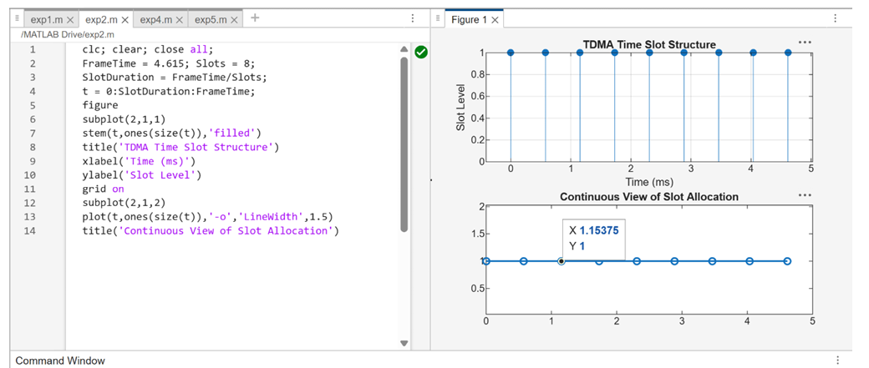
FIG .1.
• The graph shows discrete time slots arranged in a GSM TDMA frame structure with
equal spacing.
• It confirms fixed time division where each slot is allocated a specific time interval
without overlap.
Objective 2: Matlab Code and Output
clc; clear; close all;
TotalSlots = 8;
AllocatedSlots = 6;
FreeSlots = TotalSlots - AllocatedSlots;
Utilization = (AllocatedSlots/TotalSlots)*100;
disp('Frame Utilization (%)')
disp(Utilization)
figure
% Graph 1: Simple Line Plot (SAFE - no bar function)
subplot(2,1,1)
plot([1 2],[AllocatedSlots FreeSlots],'-o','LineWidth',2)
title('GSM Frame Utilization (Allocated vs Free)')
xlabel('Slot Type Index (1=Allocated, 2=Free)')
ylabel('Number of Slots')
grid on

% Graph 2: Pie Chart (SAFE)
subplot(2,1,2)
pie([AllocatedSlots FreeSlots])
title('Slot Distribution in GSM Frame')
legend('Allocated','Free')
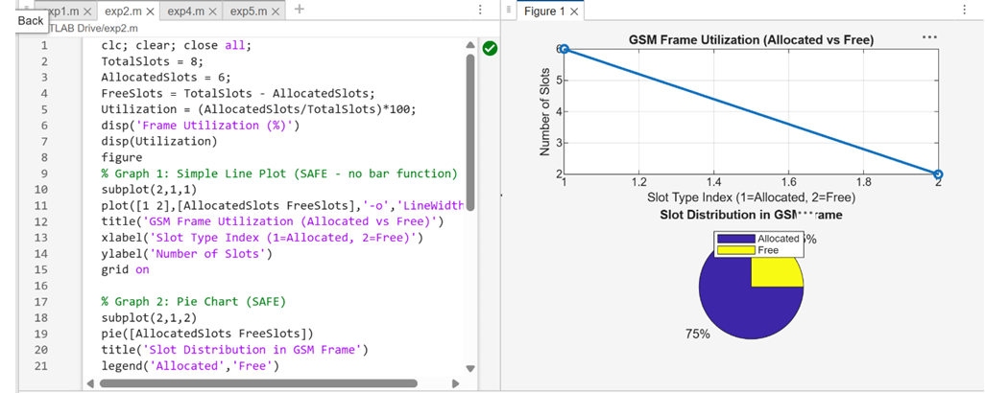
FIG.2.
The plot shows that most of the TDMA frame is allocated to active users, indicating high
resource usage.
The pie chart clearly represents that 75% of slots are utilized while 25% remain free.
Objective 3: Matlab Code and Output
clc; clear; close all;
Users = 1:8; % Total users
TotalSlots = 5; % Available slots
Alloc = zeros(1,8); % Initialize allocation
Alloc(1:TotalSlots) = 1; % Assign slots to first users
Blocked = 1 - Alloc; % Remaining users blocked
disp('User Wise Slot Allocation')
disp(table(Users',Alloc','VariableNames',{'User','Status(1=Allocated,0=Blocked)'}))
figure
% Graph 1: Allocation per user
subplot(2,1,1)

stem(Users,Alloc,'filled','LineWidth',2)
title('TDMA Slot Allocation per User')
xlabel('User Index')
ylabel('Slot Status (1=Allocated, 0=Blocked)')
ylim([-0.2 1.2])
grid on
% Graph 2: System view (safe alternative to bar)
subplot(2,1,2)
plot(Users,Alloc,'-o','LineWidth',2)
hold on
plot(Users,Blocked,'-s','LineWidth',2)
title('TDMA Slot Utilization Analysis')
xlabel('User Index')
ylabel('Status')
legend('Allocated','Blocked')
grid on
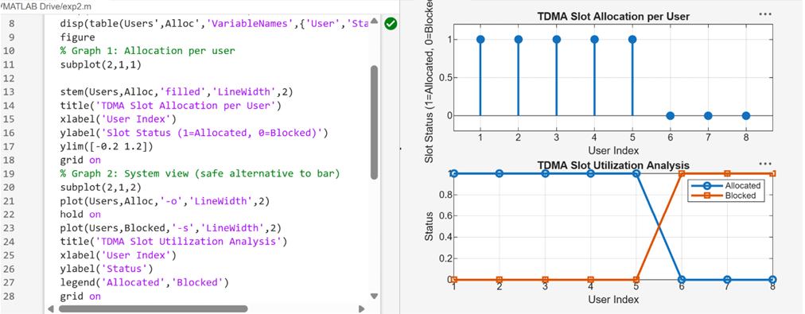
FIG .3.
The first graph shows which users are allocated time slots and which are blocked due to limited
resources.
The second graph compares allocated and blocked users, clearly showing TDMA resource
limitation.
Result:
1. The time slot duration in the GSM TDMA frame was successfully calculated, confirming
equal division of the frame into fixed time intervals.
2. The frame utilization was effectively analyzed, showing the proportion of allocated and
free slots in the TDMA system.
3. The slot allocation per user was successfully implemented, demonstrating that limited
slots are assigned to users while excess users are blocked due to resource constraints.

